Assignment 1

Graph of Education vs. Winners

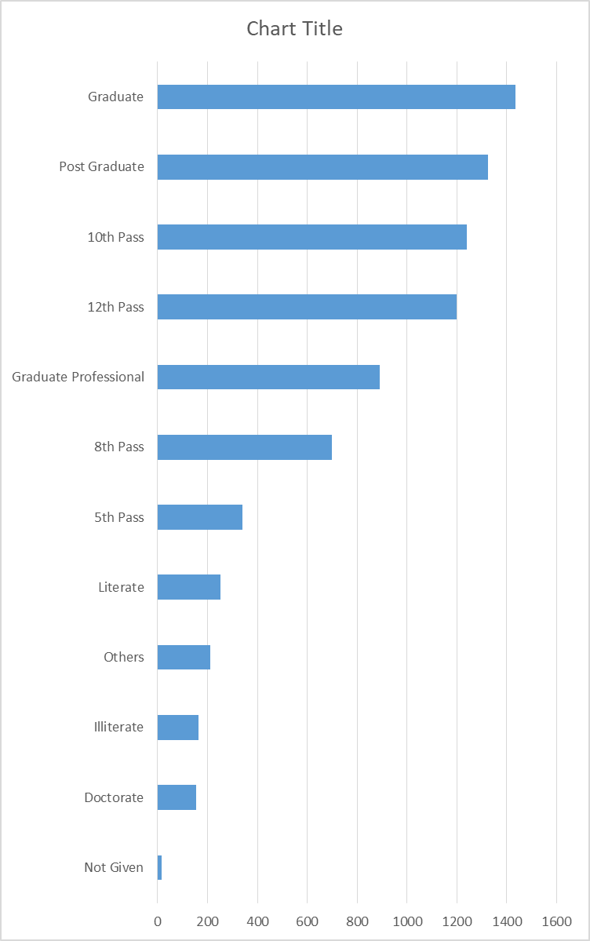

Graph of Age Vs. Winners

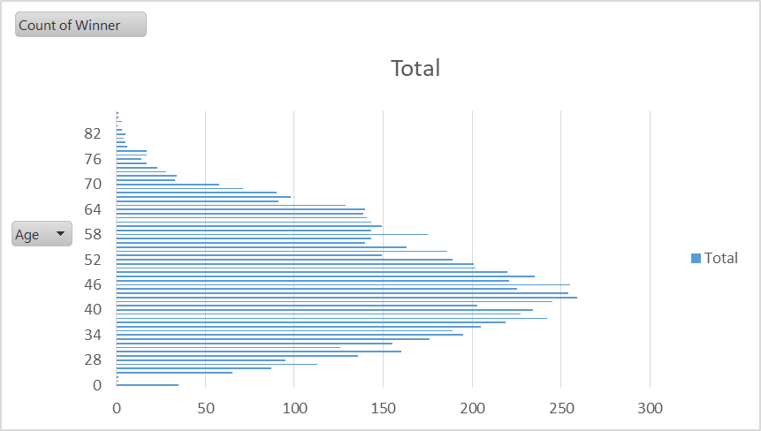

Graph of state Vs. Assets

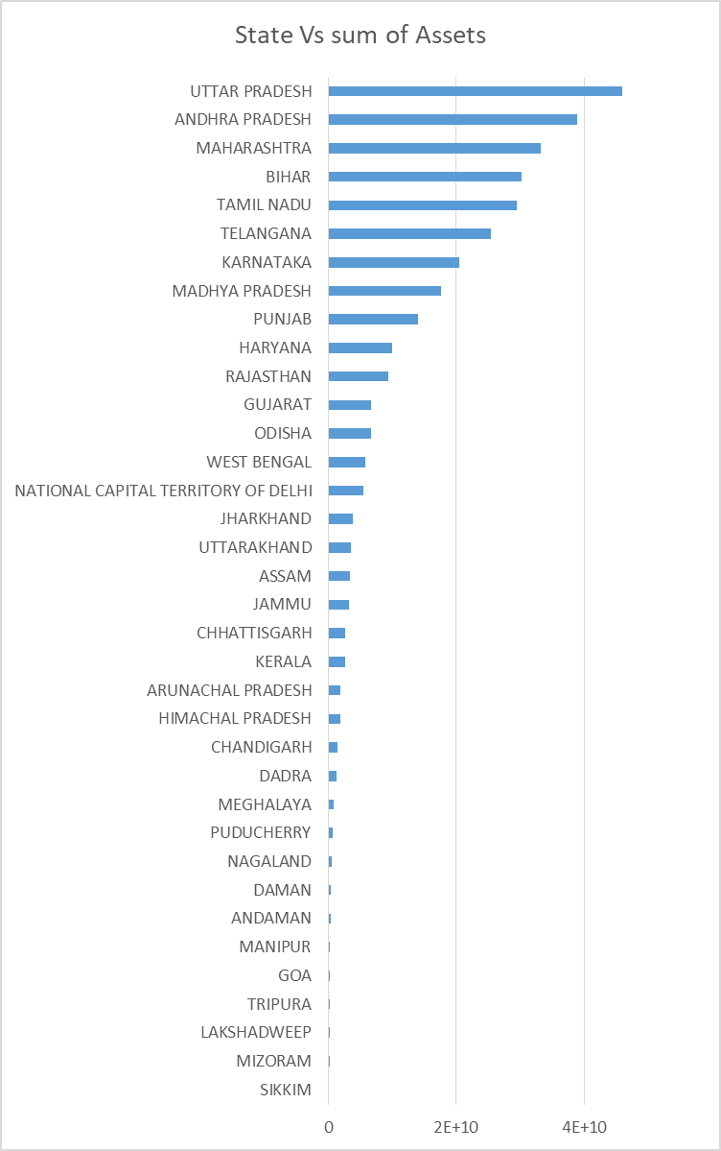

Graph of state Vs. Criminal record

